Solar Storms

***As a result of solar flares,solar winds occur, formed by charged particles in plasma, consisting of electrons and protons emitted into space from the upper layer of the Sun, called the "corona'', and affecting the magnetic field of the Earth, is called a solar storm.***

***Solar flares were first observed by Richard Carrington and Richard Hodgson independently on 1 September 1859 by projecting the image of the solar disk produced by an optical telescope through a broad-band filter.***

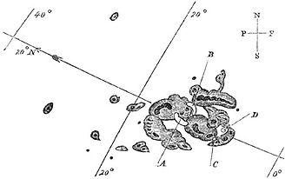

***picture’¹’***

***Richard Carrington's sketch of the first recorded solar flare (A and B mark the initial bright points which moved over the course of five minutes to C and D before disappearing***

**Solar Storm’s Results**

***Considering the previous geological storms, no harm to human health was detected.***

***GPS radio signals travel from the satellite to the ground receiver via the Earth's ionosphere. a geomagnetic storm comes into contact with the earth's ionosphere, causing disturbances in the ionosphere. When the ionosphere is disturbed by a space weather event, the models are no longer accurate and the receivers cannot calculate an accurate position based on the top of the satellites. The currents and energy brought by a geomagnetic storm strengthen the ionosphere and increase the ionospheric electron number, or Total Electron Count, integrated with the total altitude. GPS systems cannot accurately model this dynamic enhancement and errors are included in position calculations. For this reason, a possible major geologic storm will disrupt GPS systems.’¹’***

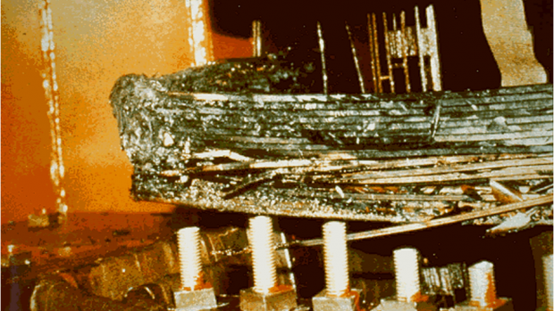

***picture’²’***

***The impact of geomagnetic storms on the power grid depends on the size of the storm. A major storm causes electrical problems in one region or even the entire world. When natural current paths are taken into account, the net geoelectric field applied to artificial current paths results in half DC current in power lines. These geomagnetically induced currents cause the 'exciting current' in power transformers to operate outside of their designed range, causing saturation of the magnetic core material inside the transformer. When the core is saturated, the transformer no longer provides any back 'electromotive force' and the currents and voltages in the windings grow abnormally. Depending on the transformer design, this can lead to ignition of surrounding structures due to induced 'Eddy Currents' which have the potential to damage parts of the transformer.’²’***

***Solar x-rays from the sun penetrate the bottom of the ionosphere (about 80 km). There the x-ray photons ionize the atmosphere and create an enhancement in the D layer of the ionosphere.***

***Radiation Storm caused by energetic solar protons in a major geological storm can also disrupt HF radio communications. Protons are driven by the Earth's magnetic field so they collide with the upper atmosphere near the north and south poles. Fast-moving protons have an effect similar to x-ray photons and form an enhanced D-Layer, blocking HF radio communications at high latitudes. During auroral images, precipitating electrons can strengthen other layers of the ionosphere and have similar disruptive and blocking effects on radio communications.’⁴’***

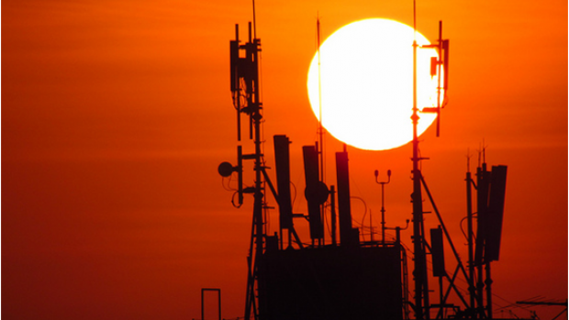

***Picture’³’***

**Northern Lights**

***In its first contact with the Earth, the geological storm directs it to the sunless side of the Earth by the Earth's atmosphere. Plasma entering the atmosphere from the poles interacts with the gas in the air and creates the northern lights.***

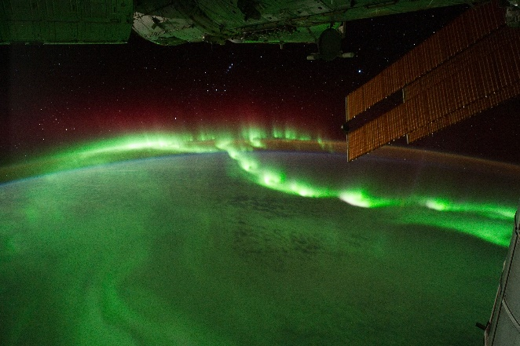***If the plasmas entering the atmosphere interact with oxygen in the air, red or green, if they interact with nitrogen, blue northern lights are seen.’⁵’***

***Picture’⁴’***

# Our Project

***With our project, we modeled the damages that the geological storm can cause to our Earth. With this model, we aim to raise awareness for possible major geological storms.***

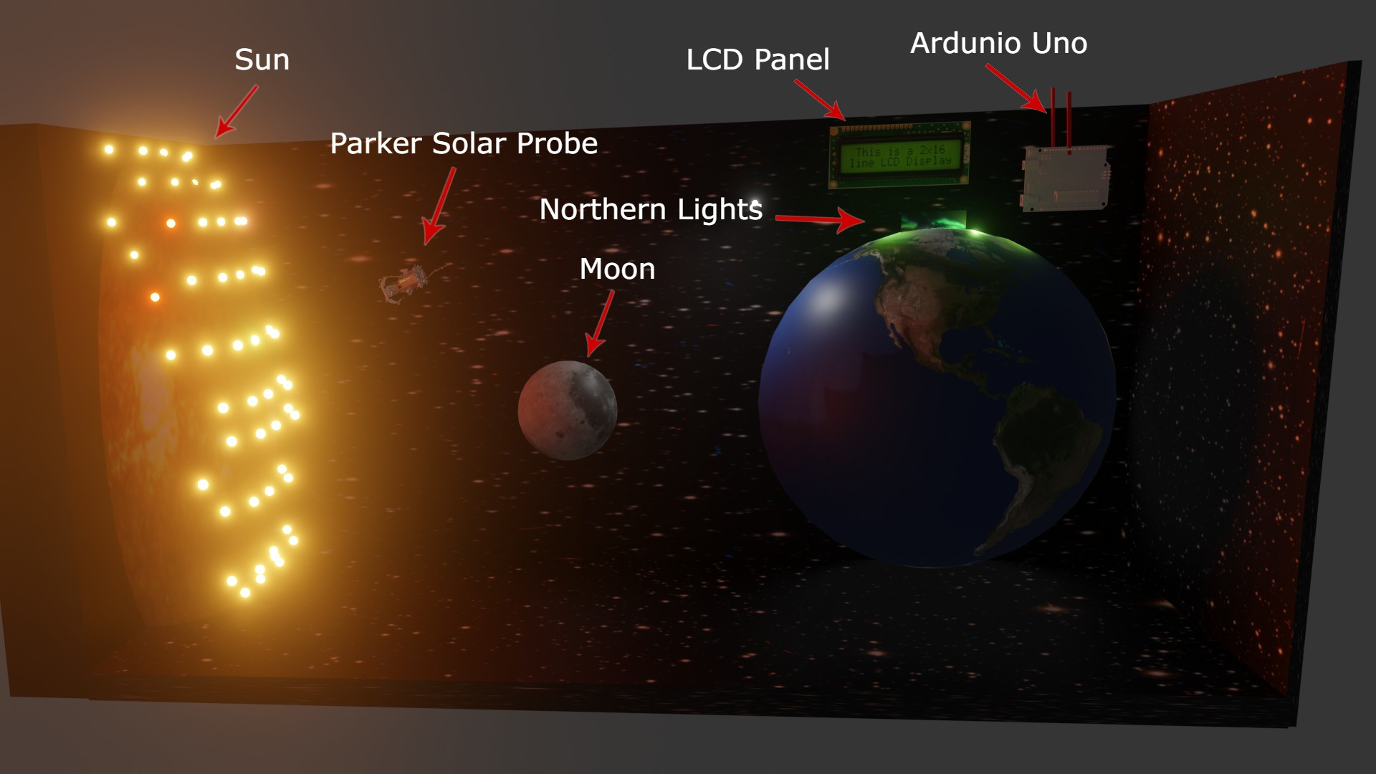

***We have developed a microcontroller-based system to continuously monitor Parker Solar Probe data and inform users. When the geomagnetic storm reached the Earth, we controlled the northern lights with a microcontroller system. We used led (light-emitting diode) for sun and northern lights. In order to transmit the data to the user, we reflected it on the screen thanks to the LCD (liquid-crystal display)***

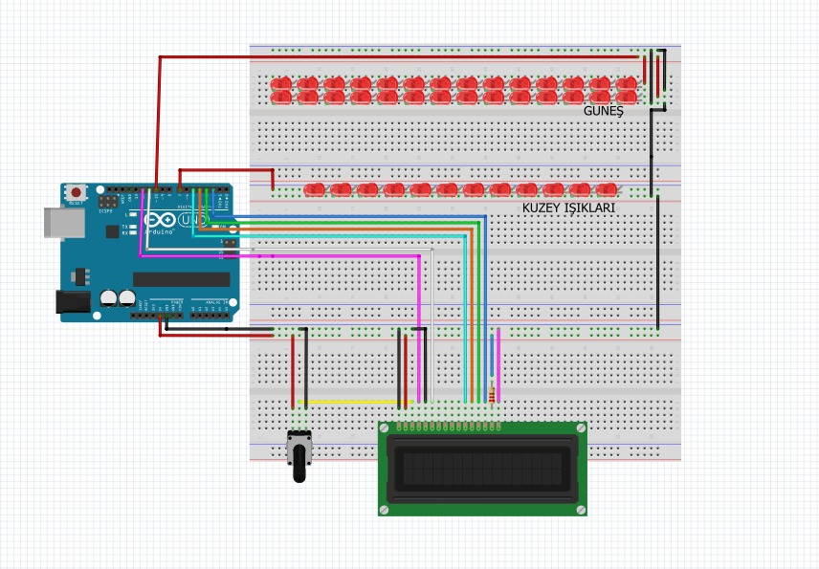





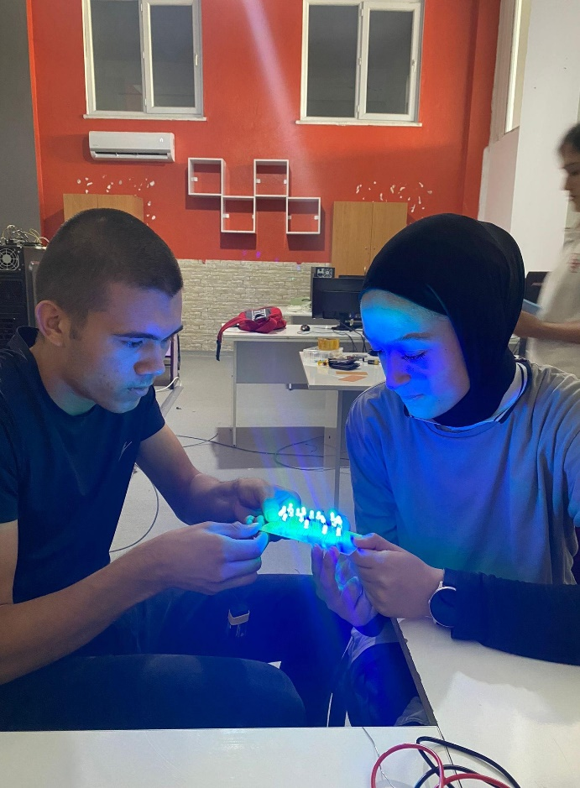



**Source**

***1)*** ***https://en.wikipedia.org/wiki/Solar_flare***

***2 )*** [***https://www.swpc.noaa.gov/impacts/space-weather-and-gps-systems***](https://www.swpc.noaa.gov/impacts/space-weather-and-gps-systems)

***3)*** [***https://www.swpc.noaa.gov/impacts/electric-power-transmission***](https://www.swpc.noaa.gov/impacts/electric-power-transmission)

***4)*** [***https://www.swpc.noaa.gov/impacts/hf-radio-communications***](https://www.swpc.noaa.gov/impacts/hf-radio-communications)

***5)***[***https://tr.wikipedia.org/wiki/Kutup_%C4%B1%C5%9F%C4%B1klar%C4%B1***](https://tr.wikipedia.org/wiki/Kutup_%C4%B1%C5%9F%C4%B1klar%C4%B1)

***Picture 1 )*** [***https://en.wikipedia.org/wiki/File:Carrington_Richard_sunspots_1859.jpg***](https://en.wikipedia.org/wiki/File:Carrington_Richard_sunspots_1859.jpg)

***Picture 2 )*** [***https://www.swpc.noaa.gov/sites/default/files/styles/medium/public/GIC_Transformer.png?itok=5ss7TKaZ***](https://www.swpc.noaa.gov/sites/default/files/styles/medium/public/GIC_Transformer.png?itok=5ss7TKaZ)

***Picture 3 )*** [***https://www.swpc.noaa.gov/sites/default/files/styles/medium/public/RadioHF.png?itok=xHG-14mi***](https://www.swpc.noaa.gov/sites/default/files/styles/medium/public/RadioHF.png?itok=xHG-14mi)

***Picture 4 ) https://www.nasa.gov/sites/default/files/thumbnails/image/iss029-e-6012.jpg***